**Introduction to Web Development**

**Deployed Javascript-enabled site (validated, tested) - Milestone Four**

**Prof. Benjamin Yu**

**Elizabeth Lee**

**Eric Sy**

**Neda Jamalirad**

**Ryan Liang**

**Table of Contents**

**IV. Deployed Javascript-enabled site (validated, tested)**

* 1. URL 2
  2. List of Completed Items 2
  3. Form Validation Requirements 2
  4. Form Testing 4
  5. Additional Work Completed 6
  6. Deviations from Previous Milestones 6
  7. Key Issues Encountered 6
  8. Widgets and jQuery 6
  9. Testing with JavaScript Disabled 7

**Appendix**

**I. Website Design**

* 1. Purpose and Goals 7
  2. Target Audience 7
  3. Content of Website 7
  4. Website Success Factors 7
  5. Critique and Comparison 8
  6. Functional Requirements 8
  7. Project Work Plan 8

**II. Site Map and Page Design**

* 1. Site Map 9
  2. Color Scheme 10
  3. Wireframes 10
  4. Prints 23

**III. Skeleton Site with Layout, Tables and Form**

* 1. Technical Design 35
  2. External Stylesheets 38
  3. Prototype Page 38
  4. A/B Testing 39

**IV. Deployed Javascript-enabled site (validated, tested)**

**URL**

http://students.bcitdev.com/A01005523/Milestone4Directory/views/index.html

**List of Completed Items**

backtop.js

cart.js

catering.js

contact.js

index.js

popup.js

products.js

signin.js

**Form Validation Requirements**

All submission fields that required server-side validation were validated upon being filled and upon submission. No alert messages were used. Fields that required validation were focused and highlighted with a red border. In addition, fields with warning messages or empty fields blocked submission. User-friendly feedback is provided.

|  |  |  |
| --- | --- | --- |
| FORM on page: Sign in | | |
| Field ID | **Data Format/RegExp** | **Explanation** |
| txtUsername | Text | * Required field – cannot be blank. * We excluded validation for the sign in form because it should **only** send a warning if the username/password combination does not match the database (which has not been implemented yet). Essentially, it would be the same RegEx as the txtNewUser field. |
| txtPassword | Password | * Required field – cannot be blank. * We excluded validation for the sign in form because it should **only** send a warning if the username/password combination does not match the database (which has not been implemented yet). Essentially, it would be the same RegEx as the txtNewPassword field. |
| txtNewUser | Text  /^[a-zA-Z0-9_-]{3,15}$/ | * Required field – cannot be blank. * It must be 3-15 characters and can only include alphanumeric characters, underscores and dashes. |
| txtNewPassword | Password  /^(?=.*[a-z])(?=.*[A-Z])(?=.*\d).{6,}$/ | * Required field – cannot be blank. * It must be 6 or more characters with at least one lowercase letter, one uppercase letter and one digit. |
| txtVerify | Password | * Required field – cannot be blank. * It must match txtNewPassword. |
| txtEmail | Text  /^[a-zA-Z\d_]+\@[a-zA-Z]+\.[a-zAZz]{2,3}/ | * Required field – cannot be blank. * An email cannot contain whitespaces. It must precede with an alphanumeric string (including underscores), followed by an @ symbol, another string, a period and ends in 2-3 alpha characters. * The last 3-4 characters must be .com, .ca or .org. |
| chkRemember | Checkbox | * No validation required. Can be in one of two states: checked or unchecked. |

|  |  |  |
| --- | --- | --- |
| FORM on page: Contact Us | | |
| Field ID | **Data Format/RegExp** | **Explanation** |
| txtName | Text | * Required field – cannot be blank. * It cannot contain numbers or symbols. |
| txtEmail | Text  /^[a-zA-Z\d_]+\@[a-zA-Z]+\.[a-zA-Z]{2,3}/ | * Required field – cannot be blank. * An email cannot contain whitespaces. It must precede with an alphanumeric string (including underscores), followed by an @ symbol, another string, a period and ends in 2-3 alpha characters. * The last 3-4 characters must be .com, .ca or .org. |
| taFeedback | Textarea | * Required field – cannot be blank. |

|  |  |  |
| --- | --- | --- |
| FORM on page: Catering | | |
| Field ID | **Data Format/RegExp** | **Explanation** |
| txtFirstName | Text  /[^a-zA-Z]+/ | * Required field – cannot be blank. * It can only include alpha characters. |
| txtLastName | Text  /[^a-zA-Z]+/ | * Required field – cannot be blank. * It can only include alpha characters. |
| txtPhone_0, txtPhone_1, txtPhone_2 | Text | * Required fields – cannot be blank. * txtPhone_0 and txtPhone_1 must have 3 digits. * txtPhone_2 must have 4 digits. |
| txtEmail | Text  /^[a-zA-Z\d_]+\@[a-zA-Z]+\.[a-zA-Z]{2,3}/ | * Required field – cannot be blank. * An email cannot contain whitespaces. It must precede with an alphanumeric string (including underscores), followed by an @ symbol, another string, a period and ends in 2-3 alpha characters. * The last 3-4 characters must be .com, .ca or .org. |
| txtOrganization | Text | * No validation required. |
| txtAddress | Text  /[^0-9a-zA-Z]+/ | * Required field – cannot be blank. * It must be alphanumeric. |
| txtDate | Text (widget) | * Required field – cannot be blank. * It must be at least 14 full days from the current date. |
| txtStartTime | Text (widget) | * Required field – cannot be blank. * It must be after 8:00AM on weekdays and must be after 10:00AM on weekends. |
| txtEndTime | Text (widget) | * Required field – cannot be blank. * It must be before 4:00PM on weekdays and must be after 3:00PM on weekends. * It must be after the start time. |
| lstFunction | Text / Datalist  /[^a-zA-Z]+/ | * Required field – cannot be blank. * It can only include alpha characters. |
| txtGuests | Text | * Required field – cannot be blank. * It must numerical. * It must be at least 50 and no more than 250. |
| chkBrownies  chkCakes  chkCookies  chkCupcakes  chkDonuts  chkMacarons | Checkbox | * No validation required. Each can be in one of two states: checked or unchecked. |
| taAllergies | Textarea | * No validation required. |
| taComments | Textarea | * No validation required. |

|  |  |  |
| --- | --- | --- |
| FORM on page: Cart | | |
| Field ID | **Data Format/RegExp** | **Explanation** |
| txtQuantity1, txtQuantity2, txtQuantity3,  txtQuantity4 | Text | * Required fields – cannot be blank. * It must be a value between 1-100 (inclusive). |

|  |  |  |
| --- | --- | --- |
| FORM on page: Products | | |
| Field ID | **Data Format/RegExp** | **Explanation** |
| txtQuantity | Text | * Required field – cannot be blank. * It must be a value between 1-100 (inclusive). |

**Form Testing**

|  |  |  |
| --- | --- | --- |
| TEST DOCUMENTATION for FORM on page: Sign in | | |
| FIELD LEVEL TESTING | | |
| Field ID | **Problem** | **Improvements Made** |
| txtEmail | It did not account for spaces. | RegEx updated to restrict usage of spaces. |
| txtVerify | Password verification did not check that the two entered passwords matched. | The original validation was the same as the password box. Validation was changed to check that the two passwords matched instead. |
| FORM LEVEL TESTING | | |
| Form Flow | **Problem** | **Improvements Made** |
| txtNewUser  txtNewPassword  txtEmail | Error messages were not clear enough. | Error messages updated with more detail on allowed/not allowed characters. |

|  |  |  |
| --- | --- | --- |
| TEST DOCUMENTATION for FORM on page: Contact Us | | |
| FIELD LEVEL TESTING | | |
| Field ID | **Problem** | **Improvements Made** |
| txtEmail | It did not account for spaces. | RegEx updated to restrict usage of spaces. |
| taComments | The placeholder was missing and JS allowed submission even when the field is left “empty.” | Tabs in HTML of textarea were removed to make the textarea element empty. |
| FORM LEVEL TESTING | | |
| Form Flow | **Problem** | **Improvements Made** |
| txtEmail | Error messages were not clear enough. | Error messages updated with more detail on allowed/not allowed characters. |

|  |  |  |
| --- | --- | --- |
| TEST DOCUMENTATION for FORM on page: Catering | | |
| FIELD LEVEL TESTING | | |
| Field ID | **Problem** | **Improvements Made** |
| txtPhone_0, txtPhone_1, txtPhone_2 | Entering incorrect values and pressing Enter on the keyboard caused the box to be highlighted, but no error message showed. | The missing lines of code for the onsubmit validation function were added. |
| txtEmail | It did not account for spaces. | RegEx updated to restrict usage of spaces. |
| txtDate | It did not differentiate between dates within 2 weeks and dates in the past. | New error message added for dates in the past. |
| txtDate, txtStartTime, txtEndTime | The warning did not update when items were selected via the widget. | Event handler changed from onblur to onchange. |
| txtEndTime | It did not return an error if the end time was before the start time. | The validation function was updated to check that the end time was after the start time. |
| txtGuests | The field allowed an infinite number without an error message. | The maximum value was added. |
| FORM LEVEL TESTING | | |
| Form Flow | **Problem** | **Improvements Made** |
| Error message | Error messages were not clear enough. | Error messages updated with more detail on allowed/not allowed characters. |
| txtStartTime, txtEndTime | The field labels were not clear. | The field labels were changed from “Start Time” and “End Time” to “Event Start Time” and “Event End Time.” |

|  |  |  |
| --- | --- | --- |
| TEST DOCUMENTATION for FORM on page: Cart | | |
| FIELD LEVEL TESTING | | |
| Field ID | **Problem** | **Improvements Made** |
| No problems found |  |  |
| FORM LEVEL TESTING | | |
| Form Flow | **Problem** | **Improvements Made** |
| No problems found |  |  |

|  |  |  |
| --- | --- | --- |
| TEST DOCUMENTATION for FORM on page: Products | | |
| FIELD LEVEL TESTING | | |
| Field ID | **Problem** | **Improvements Made** |
| No problems found |  |  |
| FORM LEVEL TESTING | | |
| Form Flow | **Problem** | **Improvements Made** |
| No problems found |  |  |

**Additional Work Completed**

* Products: a filter feature has been implemented
* Products: a modal has been implemented to allow the user to purchase products
* CSS for all forms were standardized and combined into one document (form.css)

**Deviations From Previous Milestones**

* The bakery name was changed from !DOCTYPE Desserts to Madeleine’s (logos, content, etc.) to avoid confusion
* The multiple logos now redirect to the home page (index.html)
* The skip to content link was removed
* The testimonials page was renamed to Reviews and was added to the navigation bar (current html page name has not been changed)
* The sign in and cart links have been changed to icons
* The header and footer sections were redesigned
* The index page, cart and popup pages were redesigned
* The about-us and reviews have been given background images

**Key Issues Encountered**

* Products: while the image and name of the selected product are updated in the popup, the allergy image and information do not. These additional features will be implemented and fixed later.
* Specific time validation cases: We were unable to block submission despite a warning message displayed. This was the only widget that we are currently unable to fix.
* The slideshow was not displaying because the folders within the student.bcitdev.com required that the links be case-sensitive.

**Widgets and jQuery**

Datepicker and wickedpicker widgets

We added the datepicker and wickedpicker widgets to the catering form for the 'Date of Event' and time fields (start and end times) respectively. As there are multiple ways to input a date or time (March-03-2017, 2017/03/03, 8:00 AM, 8AM, etc), we wanted to make the process as quick and seamless for both the users and the web developer. Users can easily see which month and day of the week they have selected, and they have a good variety of choice for times without having to scroll through a long list of start and end times. The web developer can operate on a standardized format for date and time.

Back to top jQuery

We added a back-to-top button with jQuery to every page, to enhance the user experience with long pages such as catering and products. This will save the user the effort of scrolling if they want to return to the top of the page. With the back-to-top animation implemented, the user will enjoy a pleasant, seamless scrolling experience.

**Testing With JavaScript Disabled**

All forms submit properly with JavaScript disabled.

**Appendix**

###### **I. Website Design**

**Purpose and Goals**

Our main purpose is to create a website for a fictional patisserie based in Metro Vancouver. As a small business, it is necessary that we invest in creating and maintaining a functional website. The advantages of a website tailored to customer needs are significant and will outweigh upkeep costs especially since none of the website hosting and design will be outsourced. Our website is not meant to replace our physical location; rather it will be of interest to a new customer-base.

In order to craft a website that is suitable for our customers, we considered long-term plans against short-term goals and accomplishments. In the short-term, our website will promote our brand and products. It will serve as an additional source of advertisement and will provide the exposure needed to maintain our competitive edge. In the long-term, we hope to build and improve customer relationships. By increasing the bakery’s popularity, we can gather more meaningful information through traffic analytics and customer feedback. This will help us understand our market, improve our services and continue to grow our business.

**Target Audience**

The target audience consists primarily of residents in the Greater Vancouver District. Since our business specializes in pastries and dessert items, we seek customers who prefer sweeter foods. Catering is available which allows our company to serve the Greater Vancouver District. There are also gluten-free, allergy-free, and organic products available for customers who have preferences and dietary restrictions.

**Content of Website**

The content of our website will consist largely of graphical elements and short textual descriptions of our products. We will also be including, but not limited to: a homepage, a products page, philosophy and a history about our company, testimonials, contact information, and a form for online membership registration. Visual content will be minimalistic in order to maximize the visual appeal of the website.

**Website Success Factors**

The success of our website will largely depend on the user’s experience. Firstly, the website and its products must be visually appealing. Presentation is key since first impressions will determine whether a customer will continue browsing. With a minimalistic design, users will not be overwhelmed by an abundance of information and can simply enjoy the overall experience. Customers are also likely to browse through our website similar to a menu so products must be eye-catching and visually appetizing. Secondly, the information should be clear and concise because our design choice limits the amount of space allocated to written sections. Lastly, the website must be intuitive. It must be functional across all platforms and the ease of access should be simple and effortless. All users should be able to purchase our products in approximately two to three clicks.

**Critique and Comparison**

After browsing several bakery websites, the first bakery that caught our attention was the Ugly Cake Shop. Initially, we were overwhelmed by the detail provided on the homepage and the navigation bar felt overcrowded. Each section heavily favors text and lacks consistency which detracts from the actual products. Furthermore, the center alignment was not preferred as the site felt congested without the use of negative space. Note that these flaws were not as prominent in the mobile version. Another aspect that we disliked was that a user was required to sign up in order to buy products. In contrast, content is easily accessible because the navigation bar directly scrolls to the desired section. Unlike other websites, one distinctive characteristic of this site was that it does not require extensive loading between pages.

Ugly Cake Shop - [http://www.uglycakeshop.sg](http://www.uglycakeshop.sg/)/

Overall, we preferred the website of St. Germain Bakery. The pictures of food are vibrant and captures the attention of its customers. There is a large emphasis on images rather than text and the static backdrop helps focus our attention. We also like the fluidity and design of the drop-down menus in the navigation bar and the slideshow. Despite this, the website is a little too conservative; the layout is clean, but rather unspectacular. They opt for a structured and rectangular look to their page whereas we prefer an abstract and minimalistic design. We also felt that content such as awards and hiring were not appropriate on the homepage and should be placed in its respective sub-pages. Unfortunately, the biggest problem is that the page does not scale well on some mobile browsers with sections either overlapping or cut off.

Saint Germain Bakery - <http://www.saintgermainbakery.com/>

**Functional Requirements**

To imitate a professional website, a catering order form and cart will be implemented so that users will be able to add and remove purchases. The users will be able to toggle and store previous dietary restriction filters upon registration. Furthermore, as the success of a business also depends on customer relationships, a testimonial and feedback section will be added. We will also include a gallery of our products for browsing purposes.

In the event that these functional requirements exceed the scope of this course, we have decided to focus our attention to user registration so that they may login and save preferences on their user account as well as comment on different products. Comments or critiques can be written in the feedback portion of the Contact Us page which will allow us to interact with our customers and improve the business.

**Project Plan**

We acknowledge that our group’s experience in web development varies. After many discussions, we agreed that we need to create both a professional and learning environment for each other to be successful. From an individual’s standpoint, our responsibilities include: 1) to keep up with lecture material; 2) to actively research information pertaining our website; and 3) to experiment with new code and features. We emphasize, however, that members can always confide in each other as an extra resource. From a collaboration standpoint, we have prioritized structure, organization and communication as marquee characteristics that our team must uphold. To help with this, we have appointed Ryan Liang as our leader because he has the most experience in programming.

We decided that we need to hold weekly meetings until the end of this project. This will ensure that we have adequate time to deal with unforeseeable delays or to implement improvements. During these meetings, each member is expected to prepare and present new content, ideas, documentation or changes to the team. In addition, we have decided to set personal deadlines for our website which will precede the due date of each milestone. If, for any reason, a group member is unable to provide the necessary work requested, the rest of the group will divide and complete the work so that the project is not postponed. All components of our project will be available through shareable mediums such as Google Drive and GitHub[1].

###### **II. Site Map and Page Design**

**Site Map**



The website organization that we have decided to use is the hierarchical layout. The home page (red) and major sections (blue) comprise the navigation bar. Our target audience is the general public, so the goal is to make the design fluid and simple. We intentionally designed our website to be shallow; that is, all sections of the website can be reached with no more than two to three clicks. The cart and user sign-in/registration are not considered to be major sections, rather they are functional components that will also reside in the header so that they can be accessed at any time. For a better quality image of the site map, please visit: <https://github.com/ericjsy/web-dev/tree/master/concept/hierarchy>

**Color Scheme**

Without question, the topic that required the most debate was the color scheme as each member had their own preference— some liked having many bright colors while others preferred simple 2-tone websites. In the end, we narrowed down our color choices to red and blue. The former represents passion and love while the latter represents serenity. After browsing through many pictures of desserts, we noticed that many photographs had darker shades (chocolates). We also noticed red more often (raspberries, strawberries, cherries etc.) compared to blue (blueberries). These were the leading factors that helped us decide our current color scheme.

From a design standpoint, the color palette that we will use is easy on the eyes. It exhibits less distracting tones to draw the user’s attention to images. The header and footer will be dark to emphasize the navigational tools while the content section will be lighter. It has a good contrast between text and background so that the writing is legible. Note that this color scheme follows the W3C WCAG 2.0 guidelines for large and small text!

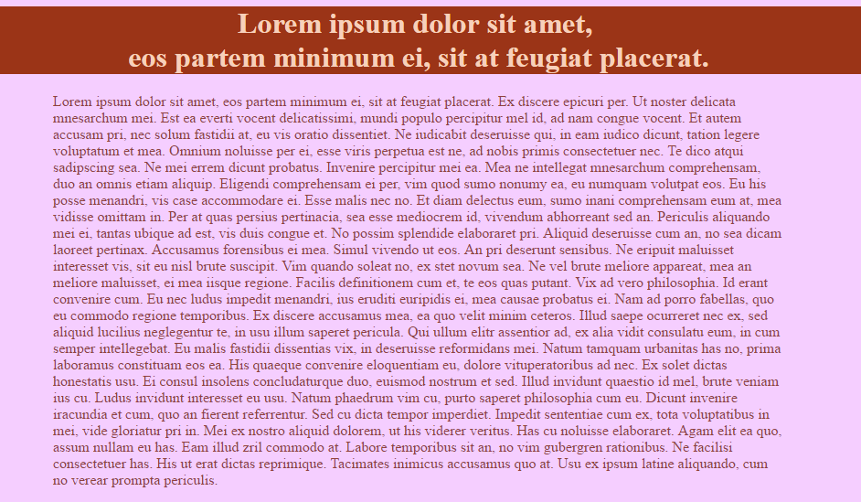

Note that this is used to represent the color scheme so the content is negligible. Body background: #F5CeFF; header background: #9B3417; body text color: #90423C; and header text color: #F7D0BB.

As this topic was a subject on much discussion and critique, please see the A/B Testing section for notes on the color scheme. It has been revised.

**Wireframes**

The features we have included may be ambitious. Whether or not this is outside of the scope of this class is yet to be determined. We will add and remove features as necessary, but the main components (Home, About Us, Products, Catering and Contact Us) are unlikely to undergo drastic changes. Also note that the ‘blank’ areas in our wireframes will either be filled in with additional information or will not exist in the final product. For a better-quality image of the wireframes, please visit: <https://github.com/ericjsy/web-dev/tree/master/concept/wireframes>

Our wireframe designs are set to a fluid website layout so that it adjusts to the user screen size and resolution. Users will be able to see a similar page on most browsers and mobile devices since our elements are not fixed but fluid. All elements are fluid except for the following: 1) on the products page, the products in the table may shift accordingly to fill the screen so that the displayed images are not too stretched out or cause the page to be too long; 2) on the cart page, the running total and the checkout button will be relative to the centre of the screen so that a long page of cart purchases will not require the user to scroll up to purchase; and 3) the back-to-top button will remain fixed in the bottom right corner so that users will be able to reach the top of the page regardless of their position on the page.

Please see the Prototype section for notes on the website layout as it has been revised since the creation of our template.html. It will retain some elements of fluidity outlined above by setting the widths to percentage values.

**Home Page**

The goal of the home page is to quickly grab the attention of customers. We will do this by having the home page load to only the header and the slideshow. This acts like a cover page: it minimizes negative space, visually draws users in to our products and gives them the option to quickly select any page on the navigation bar. The navigation bar will be horizontal and in close proximity to make navigation easier. The header will auto-hide upon scrolling and re-appear if the user hovers over the top section of the page with their cursor. This feature is to help reduce clutter. Finally, we opted to go with a single column wireframe so that we are able to maximize the horizontal space for content.



**About Us**

The about us page will use as much of the content section as possible. We want there to be a good ratio between images and text. We are proud of our roots, accomplishments and contributors, so we do not want to be stingy with the amount of information here.



**Testimonials**

The sign of any good business is through customer testimonials. We would like to showcase the support of our valued customers on this page. Each testimonial will consist of an image, a block quote and a simple five-star rating. We will moderate this page (i.e. users will not directly upload a testimonial) and we will also update it periodically.



**Products**

The products page is the most important section of our website. The majority of space in the content section is allotted to a table of high quality images. Repetition is key; we want to entice users to the wide assortment of goods that we offer. When a user clicks on an image, the products page will darken and a page will overlay with an enlarged image and a description. On the left portion of the page, we would like to include a filter box to help the user sort through products seamlessly. If we are unable to implement this feature, we will divide the products into sub-sections (cakes, cupcakes, cookies, etc.) instead for organizational purposes.



**Products Pop-up**



**Catering**

The catering form is limited to text to help the user focus on their task and to complete the form as quickly and accurately as possible. We do not want this process to be frustrating so the form is partitioned into three clear sub-sections. The fields are in a logical, step-wise order, the required information is clearly indicated and the text boxes for user input are in close proximity.



**Contact Us**

The contact page will be concise. We will include additional information that would otherwise crowd the footer section. This page will also include a section for customers to give feedback. These critiques or compliments are what we will use as data to improve the business.



**Cart**

The cart is structured so that users can easily review the products that they wish to purchase and finalize their total purchases. All information is clearly indicated and a running total is calculated. Users can also add to the quantity of their products or remove the item altogether.



**Checkout**

We simply want to thank the customer for their purchase. The checkout page will notify the user that their transaction has been completed and that a confirmation email has been sent out with their order. We contemplated adding suggested products for their next visit, but eventually voted against it because it seemed to be overbearing.



**Sign Up**

On the sign up page, one may register or choose to sign in. This site is primarily used for functionality purposes and therefore has fewer images than the other pages such as products. In addition, we chose to put the sign in and sign up side by side so that the attention of the user will be immediately split into choosing one of the two given features without having to scroll down to reach the other.



**User Accounts**

The profile page is private and will allow the user to customize their information. As shown, users are able to edit their account. We encourage users to utilize this page to make orders faster in the future. Users will be able to enter food allergies so that we can filter the products on the next visit.



**Prints**

The print-out pages will be content-oriented. It will only include the relevant information of each page. We excluded any hyperlinks including the navigation bar, cart and sign-in. We also excluded social media icons, drop-down menus and the ‘back to top’ button as these are all web-only features. We do not think they will be useful for a print out and will only take up excess space. Text and images are retained and the logo is always present. For a better quality image of the prints, please visit: <https://github.com/ericjsy/web-dev/tree/master/concept/hierarchy>

**Home Page**



**About Us**



**Testimonials**



**Products**



**Products Pop-up**



**Catering**



**Contact Us**



**Cart**



**Checkout**



**Sign Up**



**User Accounts**



###### **III. Skeleton site with layout, tables and form**

**Technical Design**

Additional work:

* We spent a lot of time on the forms indicating all required fields and have added error messages if the field is empty on incorrectly filled out. We have also started testing pattern recognition on form fields. On the catering page, for example: 1) names cannot contain numbers of symbols; 2) telephone number accepts only digits and is limited to 10 digits total; 3) email must contain an ‘@’ symbol and a ‘.com’; and 4) number of guest cannot be negative and must meet the minimum requirement of 50 guests. We plan to spend a lot of time making sure our forms are easy to use.
* The html pages were built so that popular screen resolutions and people with eye disabilities could maneuver more easily. However, we wanted to accommodate larger screens as well. The screen adjustments were not fully implemented because it was difficult to render the pages with many different formats nicely on larger screen sizes and it was difficult to access computers with different screen sizes. An effort was made so that some pages had a degree of formatting for larger screens.
* We have utilized the fotorama slideshow on the index page which automatically scrolls between images. This is the center piece of the index page so we intend to edit this as we learn more about JavaScript.
* We tried to include accessibility features on our website. Many of the navigation and fragment anchors link properly to their target destinations.
* In general, we have not implemented most things involving JavaScript. However, we have started our research. For example, the modal bootstrap technique will be necessary for the products page to transition into the ‘pop-up’ page. We have also started experimenting with JavaScript for our form pages.

**The Front Page**

Above the fold on the front page is the header and the fotorama. The fotorama fills up most of the screen with attractive dessert images and will auto-scroll. All the text in the header (including the logo) is the same colour, and meets W3C WCAG 2.0 guidelines for large and small text. The navigation links, which are contained within the header, utilize block anchors to create the effect of clickable buttons. When the browser width shrinks, the header height increases and the navigation links move down to a new line. Note that the header is fully functional without detracting from the content.

It was noticed however that fotorama slideshow was **not** visible on <ftp://ftp.bcitdev.com/Milestone3Directory/htmlpages/index.html> and therefore can only be viewed through the zip file download through Desire2Learn Dropbox

For accessibility purposes, a “Skip to Content” link has been added to the header next to the logo. Using the tabindex property, we have made this link the first item highlighted when tabbing through the page.

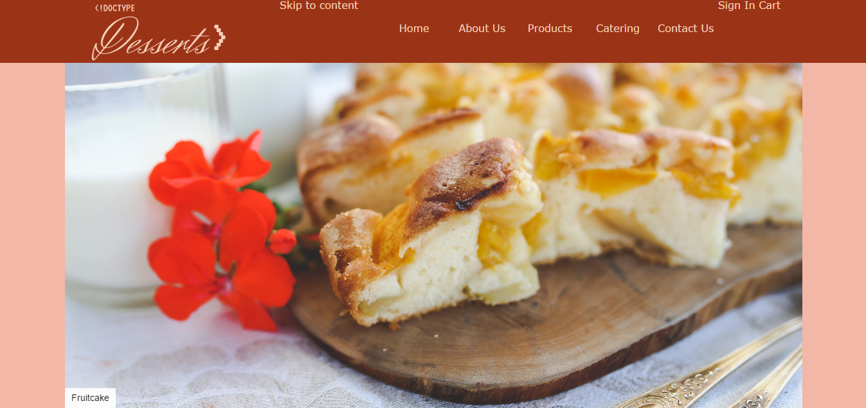

Below the fold, we present news items and special events alongside attractive photos. The font has excellent contrast and there is good use of white space. We tried to keep content short and concise and it is organized under headers and above dividers. In the bottom-right corner, a “Back to Top” link offers an efficient alternative to scrolling back up.

At the bottom of the page is the footer. The colour scheme matches the header, (aside from the text size, which is smaller). In smaller browser widths, the four columns reduce to two, then one. The links in both the header and the footer have pseudo-classes upon hovering (an underline feature in the header and color change for the footer). Note that all buttons throughout the website have a hover affect as well.

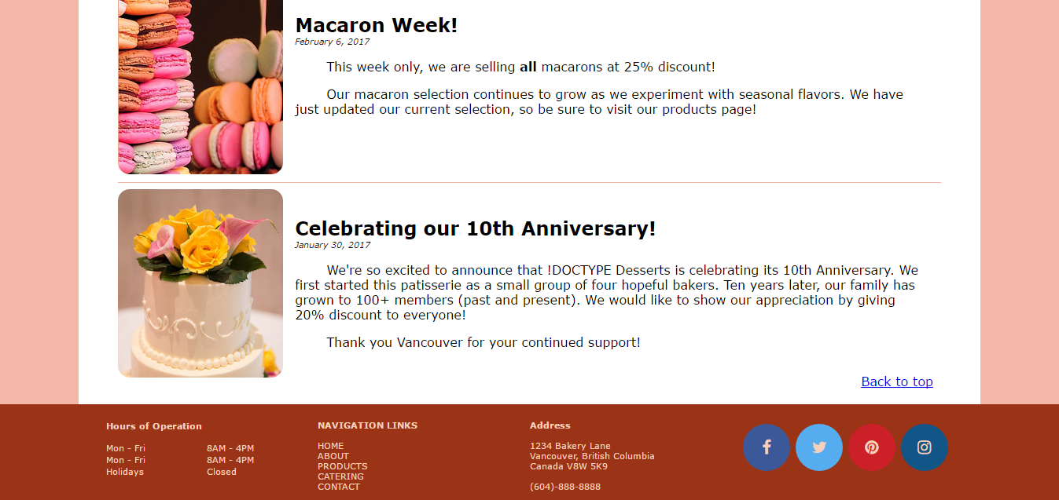

**Tables**

We have two tables on our site: the product listings on the Products page, and the Hours of Operation in the footer. Both utilize an invisible border. The table on the Products page is responsive, wrapping the data cells to the next line in smaller browser widths.

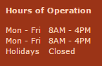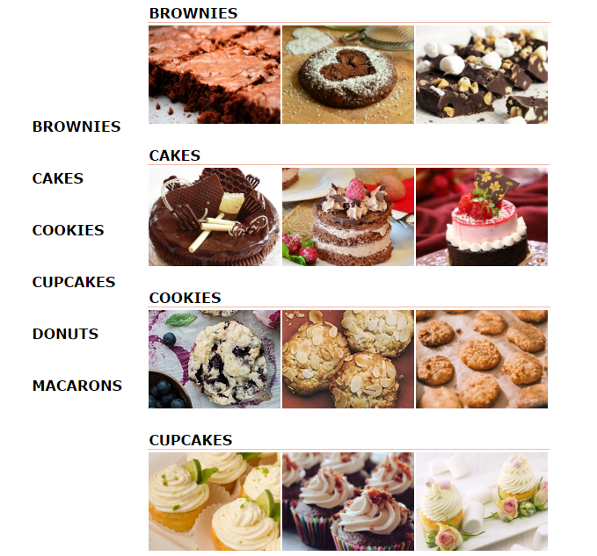

**Forms**

All the forms that include some form of submit include form elements, for example: sign-up, catering and contact us (feedback). The sign-up page is styled similarly to sign-up pages found on other websites: logging into an existing account is set to the left while signing up for a new account is done on the right. For the catering page (see image below), we took into account the F-shaped reading pattern that was recognized in Jakob Nielson’s experiment and designed the form so that all elements lie in a single column. Finally, the contact page has a small section portioned out for customers to give quick feedback. These forms were designed to utilize good proximity.

**Pictures**

We would like to note that all pictures were obtained from Flickr ([www.flickr.com](http://www.flickr.com)) and Pixabay ([www.pixabay.com](http://www.pixabay.com)). We ensured that all pictures are *public domain*. Other photos such as the specific allergy icons were self-drawn.

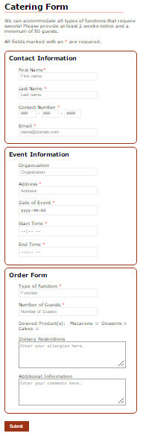

**External Stylesheets**

Most of the styling in base.css applies to the header and footer (we have separate css stylesheets for page-specific styling). We have tried to apply styles so that the page is responsive to various browser widths. Therefore, the content width is not fixed in pixel values, but as a percentage of the browser width. The header and footer heights increase as browser width decreases to accommodate the items contained in them.

We have a single stylesheet for print media. To help with legibility, we changed the font to Times New Roman and the font-size was changed to 14pt. Color is predominantly black with the exception of images. Other features, such as the fotorama, links (including the navbar, social media and sitemap) as well as buttons were removed to save paper and ink for the user.

Due to vastly different layouts between pages (such as Contact Us versus About Us), each of the pages has an external style sheet containing page-specific styles. This allows us to float divs in different places as necessary.

However, the forms have a standardized style sheet: forms.css. This ensures that the basic structure (color, spacing, buttons, etc.) of each table is the same throughout the website. For page-specific elements, we have separate style sheets: catering.css, contact.css and signin.css.

From a programming standpoint, we also decided to have separate css documents for troubleshooting. This way, if we know we need to change something specific to the template (header, footer or content layout) we look at the base.css file. Other page-specific changes can be quickly located in their respective files. It was a helpful design choice during the creation and testing of this website.

**Prototype Page**

**Deviations from Milestones 1 and 2**

After designing and testing the prototype (template.html) page, we have opted to change the layout from fluid to fixed percentage width. Since our content is quite minimal at the moment, the text looks extremely sparse when stretched to the full-page width on a wide screen. We have chosen to set the maximum width to 85% for the main body to retain a little bit of fluidity. We also feel that having vertical stripes on either side focuses the viewers’ attention towards the content section.

Given the feedback from milestone 2, we have changed the colour scheme from analogous to monochromatic. This is due to the results from our A/B Testing, in which respondents favoured the monochromatic colour scheme over the analogous scheme that we originally proposed. The text section was also changed to white to add better contrast. See the A/B testing section for more details.

In our original layout, we displayed the footer in 3 columns. Due to the size of the social media icons, we have decided to put them in a separate column, bringing the footer contents to four columns.

**Key Issues Encountered in Building the Site**

We spent a long time making the page layouts responsive to different browser widths. We encountered many persistent problems with divs jumping out of container elements; but once we fixed the issue, we felt incredibly empowered.

**A/B Testing**

In reviewing our web design, one aspect that we decided to test via A/B Testing was our color scheme. Choice A uses the colour scheme we proposed in Milestone 2. For choice B, we removed the purple colour and instead used a white background with black text for the content section. We stated in Milestone 1 that our target demographic is everyone; according to the textbook, neutral colors appeal to everyone, so we decided to add white to our design. The final design for choice B uses a red tint for the body background and white for the content background, while retaining the dark red colour for the header and footer backgrounds.

We interviewed a total of 23 people (family, friends and colleagues) and the consensus was in favor of type B (15/23). The most interesting result is the fact that the older demographic unanimously selected the second version and explicitly cited legibility as the leading factor for their vote. Other compliments included the good use of white space as well as the added 'pop' that a white background gives to pictures and sections with color (text and logo in the header). Those who did not choose B explained that a pure white background can be too straining on the eyes. Although we attribute this to the brightness of their screens, it is a valid argument and have considered using other neutral colors, such as beige, as another test.

Figure Choice A of our A/B Test. This utilizes our original colour scheme proposed in Milestone 2.

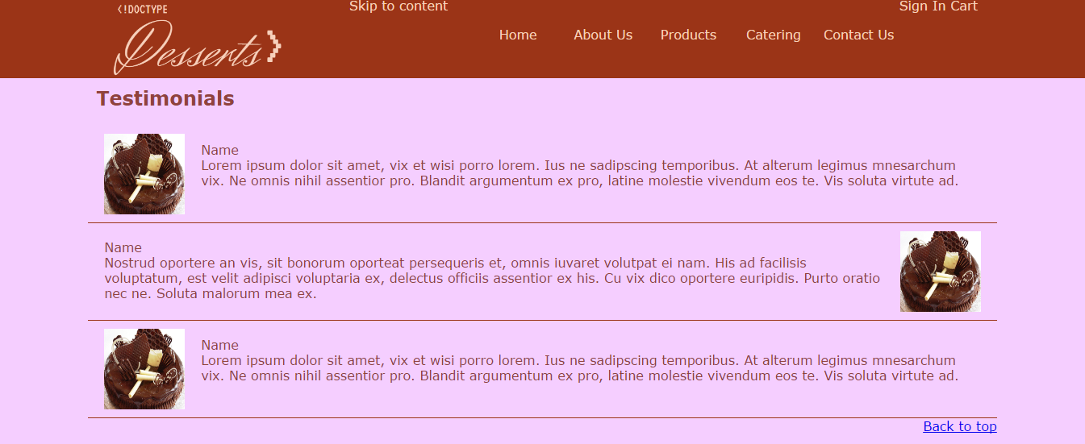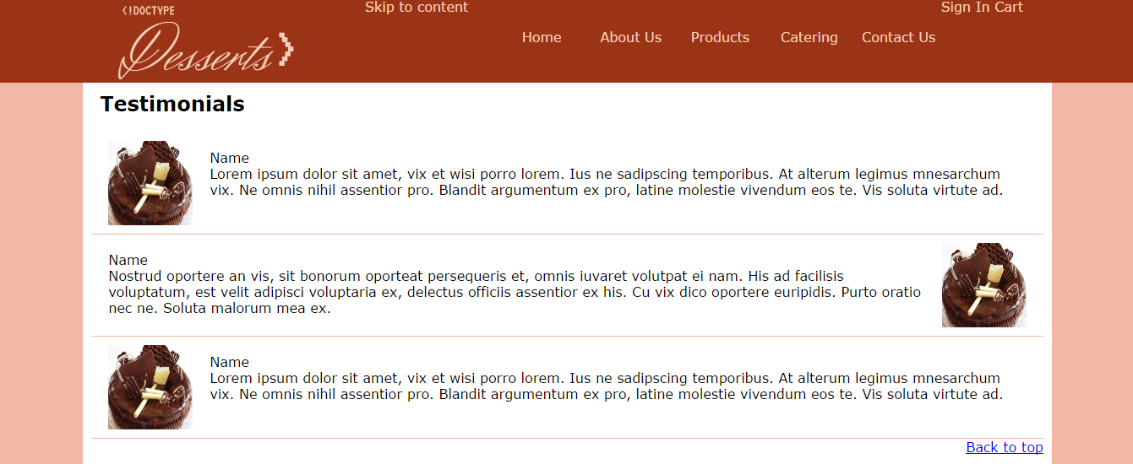

Figure Choice B of our A/B Test. A monochromatic design that includes black text on a white background for the content section.

**Summary of Completed Items for this Milestone**

HTML:

* about.html (missing images)
* cart.html
* catering.html
* checkout.html (currently a placeholder, missing JavaScript and content)
* contact.html
* index.html
* popup.html (waiting for JavaScript Modal implementation)
* products.html
* signin.html
* template.html (prototype page)
* testimonials.html (missing content and images)
* useraccount.html

CSS:

* base.css
* printbase.css (print layout)
* CSS page-specific styles (one for each HTML page, except template.html)

Validation: ALL html and css pages have been validated with no errors! No validation icons were included since it was not specified.

1. https://github.com/ericjsy/web-dev